Full Stack Development

# 22AIE457 – Assignment 1

1. Create a **responsive card component** using **HTML & CSS** with the following specifications:

The card should have **multiple layers** (background, image, and content).

On **hover**, the card should:

* 1. **Expand slightly** (scale effect).
  2. **Show a shadow effect**.
  3. **Reveal additional content** (such as a description).

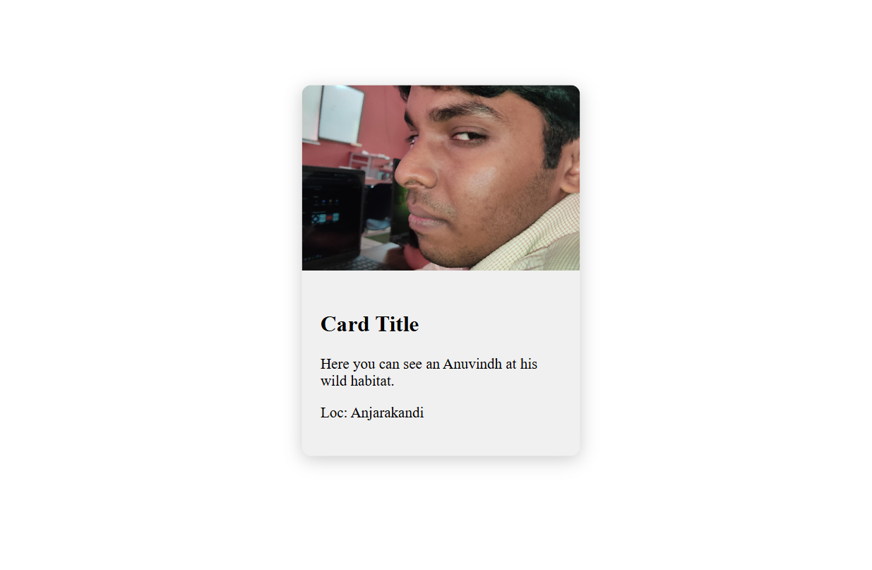

1. Create a table with a **weekly schedule** for a college timetable.

Use **colspan** and **rowspan** to merge relevant cells.

Add inline styles for table borders and background colors.

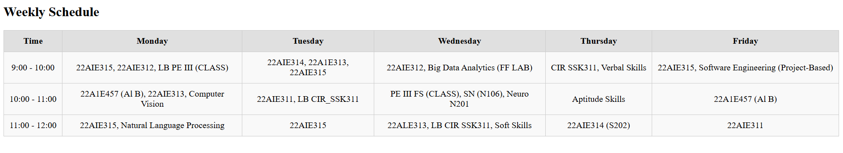

1. Create a form with the following fields:

**Name** (text input)

**Email** (text input)

**Phone Number** (text input)

**Message** (textarea)

**Gender** (radio buttons)

**Country** (dropdown menu)

**Submit** and **Reset** buttons

Use the <fieldset> and <legend> tags for grouping fields.

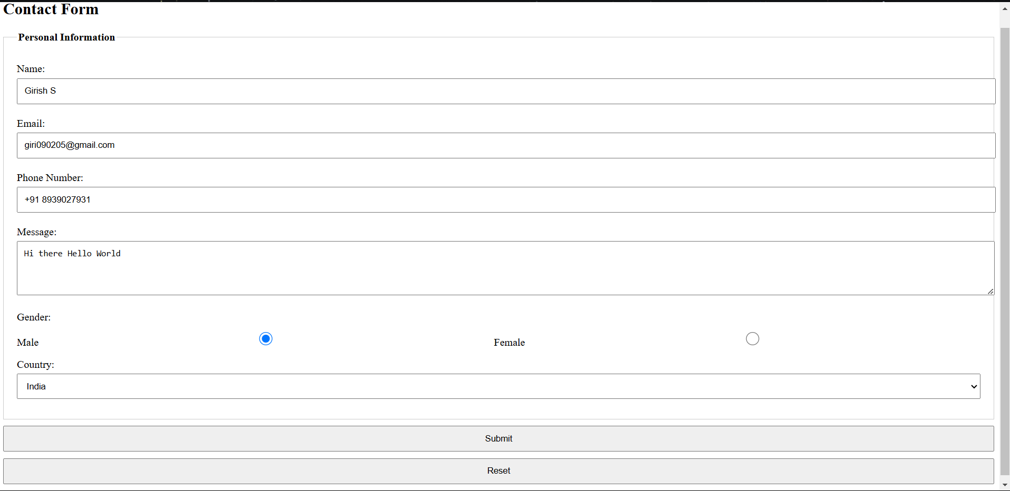

1. Create a page with sections: "About Me," "Projects," and "Contact."

Use the <font> tag to set text colors and sizes.

Apply inline **background colors**, **text alignment**, and **borders**.

